**Computer Visualization of Optical Network Behavior**

Han Dong

**1 Introduction**

My initial motivation in doing a undergraduate research project was to expand my horizon beyond the daily academics and engage in something more profound. That is when I decided to contact a professor at my department and I came to this research topic under the guidance of my faculty mentor, Professor Ray Chen. This research involves the designing and coding of a visualization software application that will be utilized to study optical network behavior from simulation data generated under the Generalized Multi-protocol Label Switching (GMPLS) management model. The GMPLS management model uses a set of control parameters to optimize the network traffic control and management processes to yield the most efficient operation of the network [2]. The network simulation research is to study and identify the proper management model and control parameters. The intention of the visualization program is to show dynamically how traffic is distributed and travelling through the network. It can provide much insight on how the control parameters perform and can suggest how to adjust the parameters to achieve improved traffic engineering.

In today’s world, the need for fast and error free transmission of data is precedent, especially in the area of internet traffic. This has led to the widespread deployment of fiber optical networks based on wavelength-division multiplexing (WDM) technology [1]. WDM is a technology that lets data be transmitted optically on a variety of channels multiplexed on a single fiber. The channels are composed of non-overlapping wavelength or frequency bands, and each band is operating at its own desired rate. This enables one to tap into a source of huge bandwidth, while also face with problems of efficient and intelligent network design, architecture and protocols in order to contain the cost in network deployment. Modern day networks based on WDM technology consists of a meshed topology, with the addition of optical add-drop multiplexers (OADM) and optical cross-connects (OXC) for wavelength routing and switching [3]. In a WDM network, users may communicate with one another through an all optical channel; also known as a lightpath. A lightpath may consist of multiple fiber links, however in cases where such paths are physically far from each other in the topology, there are usually intermediate nodes set up as optical bypasses to support the lightpath as well as providing wavelength routing. Wavelength routed networks offers increased routing flexibility along with cost savings through the elimination of optical-electrical-optical (OEO) transceivers (transmitters and receivers) at intermediate nodes. Recent advancements in technology have enabled wavelengths to carry data at a rate of 10-Gigabits and higher. The elimination of OEO transceivers in intermediate nodes brings up the issue of flexibility of wavelength routed versus traditional IP routed networks. Since a lightpath may only be used for communication between a dedicated source and destination pair of nodes, it cannot be shared with other traffic of different sources and/or destination. There is also the issue of wavelength-continuity constraint, where a lightpath operates only on the same wavelength across all fiber links, thus two lightpaths that share a fiber link cannot use the same channel (wavelength). Furthermore, internet traffic usually requires less than the available bandwidth so unused bandwidth on a lightpath goes to waste.

IP routed networks utilize a store-and-forward mechanism that terminates optical signals at each node and processes the data for routing [4]. Each node consists of routers and switches that are capable of handling huge amounts of traffic bandwidth. However in such a network, the number of OEO transceivers is proportional to the number of wavelength channels for each node. It is very costly to equip an IP routed network for dense WDM channels. In the case of a network topology consisting of N nodes, suppose each node is equipped with N-1 transceivers and if there are enough available wavelengths on all the fiber links, then every node pair could be connected by a lightpath, in this case there would be no networking problem to solve. However, transceivers are expensive, so in reality each node may only be equipped with a few of them and the number of wavelengths available on each fiber link is also limited [1]. Furthermore, it has been observed that a large portion of traffic in an IP routed network is only utilizing the transceivers to do bypassing, which is a waste of resources and costly as well. Under these conditions, given a set of lightpaths and limited wavelength channels, determining how lightpath routes are to be set up and which wavelength channels to use in order to optimize lightpath usage is important. In situations where lightpaths cannot be set up due to constraints on the wavelength channels, this is known as wavelength blocking. In this regard, the intelligent traffic engineering helps to determine efficient resource allocation while minimizing blocking probability.

**2 Network Research**

The network model I’m studying is a multi-layered GMPLS network model proposed by Dr. Aihua Guo [5]. The optical switches and electronic routers are coordinated together to achieve a dynamic solution for intelligent traffic engineering. In the GMPLS network management model, the network consists of edge nodes and core nodes. The edge nodes are usually located on the boundaries of the network and its job is to collect and transmit packets within and across network domains. The core nodes typically reside in the inner area of the network, its main job is to route traffic to its correct destination within its own network domain. An integrated optical-electronic switching layer is added at core nodes in the GMPLS network. The electronic switches will perform switching and store-and-forward mechanisms. This design will dynamically reconfigure the routing paths during heavy traffic loads by providing differentiated Quality of Service (QoS) either through an all optical bypass, or layer-2 switching and layer-3 store and forward mechanisms. The electronic switch can also perform wavelength conversion at core nodes to avoid wavelength blocking [5]. Under these circumstances, the intelligent traffic engineering is the network control and management decisions to bypass or interact at a node in order to optimize network resource allocation.

**3 Network Visualization Study**

My research involves the designing and coding of a visualization application that can be used to analyze the multi-layered GMPLS network model. Typical research in network design only generates statistical data at the end of simulations; such as the total throughput, the blocking probability, etc. Based on the statistical results, conclusions are made on the best model, control rules and parameters. This approach does not shed light on how the network is performing the traffic engineering as new traffic enters into the network, where the hot spots are located and what is the best way to deal with that. Therefore in many cases the adjustment of control parameters was done in the dark. By visualizing how the traffic is processed and routed within a network continuously, we are able to analyze the traffic distribution among core nodes as we vary control parameters. The network is based off a 32-node National Science Foundation Network (NSFNET), where each fiber link in the topology has 40 wavelength channels and a line transmission rate of 10-Gigabits per wavelength. The topology consists of fifteen edge nodes and sixteen core nodes. Each node consists of six different data attributes:

* node-blocking
  + The current blocking probability of the node. Blocking events are caused by the wavelength continuity constraint.
* node-oeo-port-util
  + The current utilization ratio of the optical-electrical-optical port. The OEO port allows the switching of optical paths by directing packets to the electronic layer.
* node-oeo-traffic-bw-ratio
  + The ratio of the amount of traffic directed to electronic switching layer compared to bandwidth available.
* node-ooo-traffic-bw-ratio
  + The ratio of traffic utilizing all-optical bypass compared to bandwidth available.
* node-unused-bw-ratio
  + The ratio of unused bandwidth.
* total-requested-bw-per-node
  + The amount of bandwidth requested by the rest of the network for that node.

The visualization application is written in Java and utilizes the following open source graphical packages; Prefuse and profusians.

***3.1 Project Progression***

I began the research project by familiarizing with the open source graphical packages. I also began reading on fiber optical network technologies and its various uses; this enabled me to further understand the core concepts and benefitted me in my design decisions. The initial prototypes involved the correct reading and parsing of input data along with the design of the network layout, these include the graphical user interface and the graphical representation of a network. I met frequently with my faculty mentor to discuss the direction of the visualization application. Changes made during the development involve modifying the data in order to accommodate additional information to be displayed. At the final stages of the development, we began analyzing the simulation results to discover how well the proposed GMPLS network is performing traffic engineering.

***3.2 Network Simulation Visualization Software***

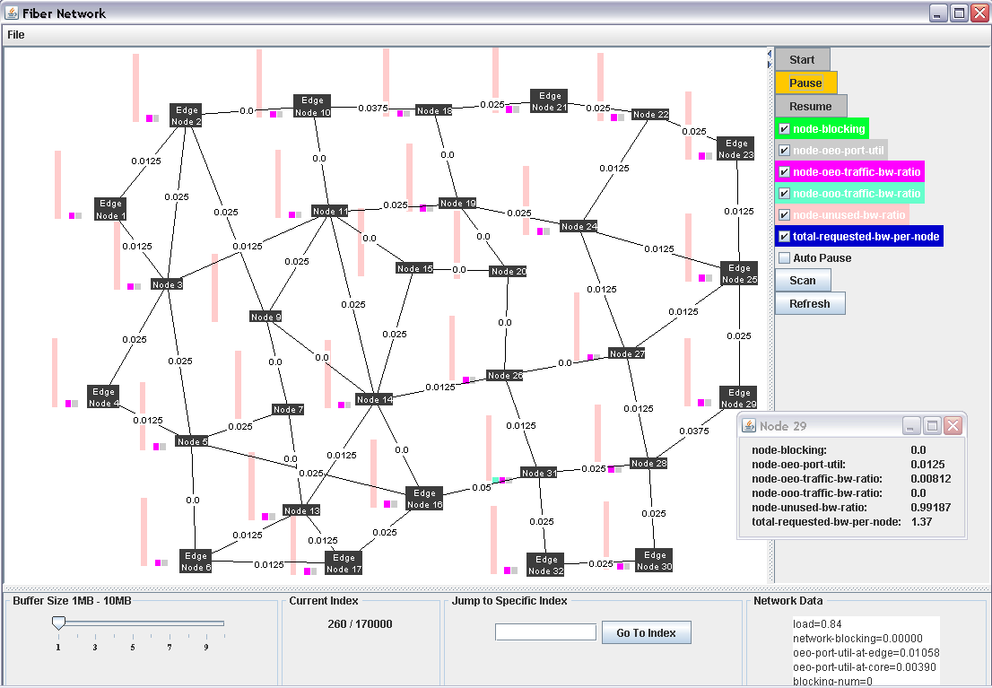

**Figure 1. Screenshot of network visualization application.**

Data utilized for the visualization is randomly generated; such as amount of requested traffic at edge nodes, packet source and destination addresses, size of packets etc. The core nodes route traffic within the network according to a set of traffic engineering rules that seek the optimal path to packet destination. The main goal of network visualization is to identify hot spots in the model where inefficiencies in the topology or traffic engineering rules that result in blocking events. By identifying these events, we are able to arrive at solutions that will further improve the overall performance of the network.

**4 Results**

**Figure 2.** **Initial NSFNET network topology.**

From visualization study of traffic flow, topological deficiencies in the initial network model was detected . First, core nodes 8 and 12 were underutilized. The node-unused-bw-ratio attribute remained at a constant ratio of 1.0 for both nodes as traffic load increases. The wavelength-usage-ratio and node-oeo-port-utilization attributes both remained at 0, which indicated no traffic routing takes place. It is wasteful and costly to have transceivers nodes that are underutilized. Thus, they were removed from the topology. In addition, edge node 23 does not have connections to core nodes for packet forwarding. The solution was to change edge node 22 into a core node. The next issue is at edge nodes 5, 16 and 31. Since the traffic engineering rules prefer lightpaths along edge nodes, as there are more oeo tranceivers in the edge nodes, the three nodes linked together act as an information super highway that causes the routing algorithm to largely ignore edge nodes 6 and 17. A solution is to change edge nodes 31 and 5 to core nodes so traffic grooming in the region can be promoted. This enabled edge nodes 6 and 17 to be more involved in traffic routing.

**Figure 3. Updated topology with changes from original network model. Notice that edge nodes 32 and 30 are isolated from rest of network. Furthermore, their wavelengths are all used up; indicated by the max ratio of 2.0 for fiber links.**

In the updated topology, initial blocking events occurred at edge nodes 32 and 30. Both nodes were relatively isolated from rest of the network. There was no other way for them to forward packets other than through links to nodes 31 and 28 respectively. Furthermore, if a heavy load of packets was incoming, the wavelengths would be utilized quickly and this results in blocking to the source node. Evidence of this is seen in the visualization, the wave length ratio in that region was the first to hit a max ratio of 2.0. The bandwidth usage ratio for the links between nodes 31 to 32 and 28 to 30 was among the first to hit a max ratio of 2.0 as well. In addition, the visualization showed that the initial blocking events were the result of nodes trying to send packets to edge nodes 32 and 30. In light of these issues, we add an additional fiber link to connect edge node 16 to node 32 (Figure 4). By doing this, edge nodes 32 and 30 have one more path to forward traffic and will not be as isolated as before.

**Figure 4. Updated topology with additional link from node 16 to 32. Links around node 15 are underutilized. Edge node 16 is very busy forwarding and routing packets.**

By inclusion of an additional link between nodes 16 to 32, a significant delay in blocking events resulted. In the prior topology, the initial blocking events appeared around indexes in the region of 43000. In the current topology, the initial blocking events appeared around indexes in the region of 75000. This indicates that the additional link helped to route traffic in the region which resulted in delaying the blocking events on the network as a whole. However, another problem arises with the underutilization of nodes 11, 14 and 15. This occurrence can be attributed to the algorithm used for traffic routing, which is based off Djikstra’s Shortest Path First Algorithm. In order for nodes 11 and 14 to route traffic from west to east, there is no benefit in doing an additional hop to 15 when they could forward to nodes 19 and 20 respectively. Our solution to this is to add additional links between node 9 to 15 and node 20 to 27. By doing this we hope to promote traffic grooming in the area and allow better utilization of core nodes for traffic routing. In addition, edge node 16 was heavily involved in packet forwarding through the rest of the network and it was also one of the earliest nodes to cause wavelength blocking. This indicates that a huge amount of traffic is being routed through it since it is connected to five other network nodes. One possible solution is to change the one or more 10-Gigabit links between node 16 and 14 to a 100-Gigabit link. We are exploring this new idea as a way to deploy and utilize the new super transponder (100G ) technology.

**5 Interpretations of Findings**

The network simulation was very successful in providing a close look at how traffic is distributed and travelling through the network. It has functionality that will not only provide a general look at the network, but also provide a very fine grained approach. The packets are generated at the edge nodes and forwarded to the core nodes where they are routed according to a set of traffic engineering rules that seeks to find the optimal path to their destinations. The visualization was able to point out potential faults in the topology design, which was not part of its initial design goal. As the traffic load got heavier, network model and control parameters had a harder time doing traffic grooming; which resulted in wavelength blocking events where a path to a destination node cannot be formed and the packet(s) was dropped. With each update to the network model, we hope to decrease the overall blocking probability of the network.

**6 Future Work**

In the study of optical network behavior, we've only begun to analyze the intricate details of network engineering. There are still many traffic engineering rules whose impacts are hard to identify in our current visualization study , and future work would be focusing on making them more obvious to researchers. Another important point is the analyzing of the traffic routing algorithm. The traffic routing algorithm is based off Djikstra's Shortest Path First Algorithm; further analysis will tell us how the algorithm is affecting traffic routing. The visualization application can be further improved upon by increasing the performance of the program through other multi-threading technologies. The user interface can also be improved upon. Additional work will involve the integration of the 100-Gigabit (super transponder) link in the network; while the technology is new and expensive to implement, if we are able identify specific links where there are high amounts of traffic being transported, the 100-Gigabit links will definitely provide a better performance for the network as a whole.

**7 Conclusions**

The network visualization application aided us in the study of network design. By providing a live animation of the progression of traffic routing in the multi layered GMPLS model, we were able to identify hotspots that impeded successful routing of packets. These hot spots corresponded to wavelength blocking events. Furthermore, we identified nodes that were underutilized, which indicated a deficiency in the design of the network topology. Based on the modifications we made with the help of the network visualization application, we were able to decrease the blocking events in the network. Finally, the visualization also enabled us to identify potential candidates for the latest 100-Gigabit fiber links.

       However, the application itself does have some limitations as well, most notably in terms of performance; when the amount of data being processed is too large it has a direct effect on the display of data. Another important issue is that it is very difficult to get a grasp on every single decision the routing algorithm makes in the network, since the visualization can only show us a broad picture.

**References**

[1] B. Mukherjee. Optical Communication Networks. McGraw-Hill, 1997.

[2] E. Mannie, "Generalized Multi-protocol Label Switching Architecture", RFC 3945, Oct. 2004.

[3] Optical Network, "OADM", Optical Hub. 8/7/2006 <http://www.optical-network.com/terminology.php?letter=all&id=8>

[4] A. S. Tanenbaum. Computer Networks. Prentice Hall, March 17, 2003.

[5] A. Guo and Y. J. Chen, "Traffic Engineering with Quality-of-Service in Multi-Layer GMPLS Optical Networks". 2006.